|  |  |  |
| --- | --- | --- |
|  |  | |
| Telensa-Logo-RGB-HiRes  **RFI RESPONSE**  **PrePARED FOR**  **CITY OF PITTSBURGH**  **Office of Management & Budget**  ***on behalf of the***  **Department of Innovation & Performance**  1024px-Seal_of_the_City_of_Pittsburgh  **Prepared by**  **Telensa, inc.**  **1200 Abernathy ROad NE**  **Suite 1700**  **Atlanta, GA 30328**  **April 10, 2017** | |  |

Table of Contents

[1. Introduction 1](#_Toc479575051)

[2. The benefits of incorporating Telensa PLANet in an LED deployment 1](#_Toc479575052)

[3. Telensa PLANet components 2](#_Toc479575053)

[4. Energy Saving Strategies Enabled by PLANet 2](#_Toc479575054)

[5. Business case breakdown 3](#_Toc479575055)

[6. PLANet CMS: comprehensive, proven and scalable 4](#_Toc479575056)

[7. Telensa UNB – the reason why Telensa Smart Lighting is the Market Leader 5](#_Toc479575057)

[8. Telensa UNB – Future Proof Smart City Network 6](#_Toc479575058)

[9. Telensa Smart City – ready for whatever happens in smart cities 7](#_Toc479575059)

[10. Rapid Interfacing Methods 7](#_Toc479575060)

[11. What services can I add to my smart city system? 8](#_Toc479575061)

[12. City-Directed Small Cell Network 9](#_Toc479575062)

[13. Telensa – Innovation Being Implemented Today 9](#_Toc479575063)

[14. Telensa – Delivering a Proven Platform NOT a Pilot 10](#_Toc479575064)

[15. Conclusion 10](#_Toc479575065)

# Telensa

## 1. Introduction

Telensa makes wireless smart city applications, including PLANet®, the world’s most deployed smart streetlight solution with a global footprint of over one million lights. PLANet pays for itself by reducing energy and maintenance costs, it future-proofs LED investments, and it delivers a dedicated smart city network with no additional investment.

Leading municipalities and utilities are working with Telensa to deploy smart city applications including traffic analytics, asset and environmental monitoring, smart grid applications such as demand-response and a host of other “city-centric” applications designed to deliver real operating efficiencies.

Telensa’s Ultra Narrow Band (UNB) radio combines low cost, wide area coverage and long battery life for massive numbers of devices. UNB is undergoing standardization with ETSI.

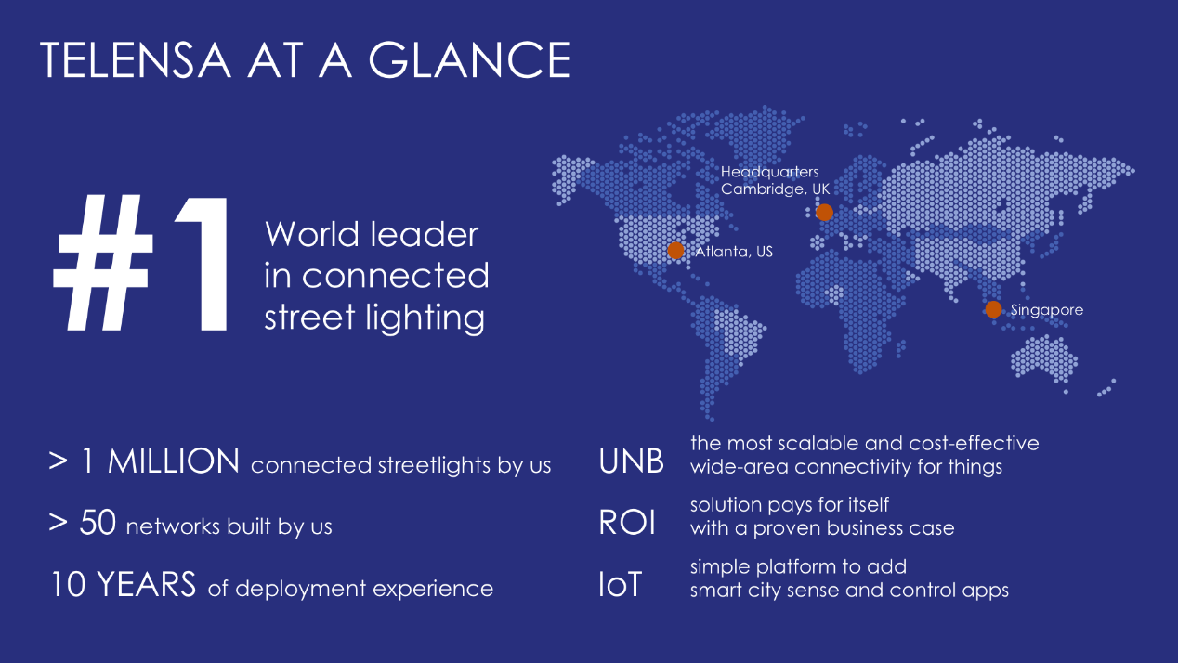

## The benefits of incorporating Telensa PLANet in an LED deployment

* **Greater energy savings**  
  CMS adds savings of at least 30% in addition to the savings from LED.
* **Fewer non-working lights and day burners**  
  Because connected lights report their status and raise alarms in real time.
* **Optimized maintenance**Replaces night scouting. Eliminates 24hr response. Avoids false and multiple visits. Optimizes crew and parts logistics. Central analytics optimizes planning.
* **Lighting optimized for each location that evolves over time**Complete flexibility in central control programs, light levels and event overrides
* **Future-proofs the LED investment**Enables the addition of smart city sensors and multiple monitoring and control applications. Offers secure facility to share infrastructure (with customers and utility).

## 3. Telensa PLANet components

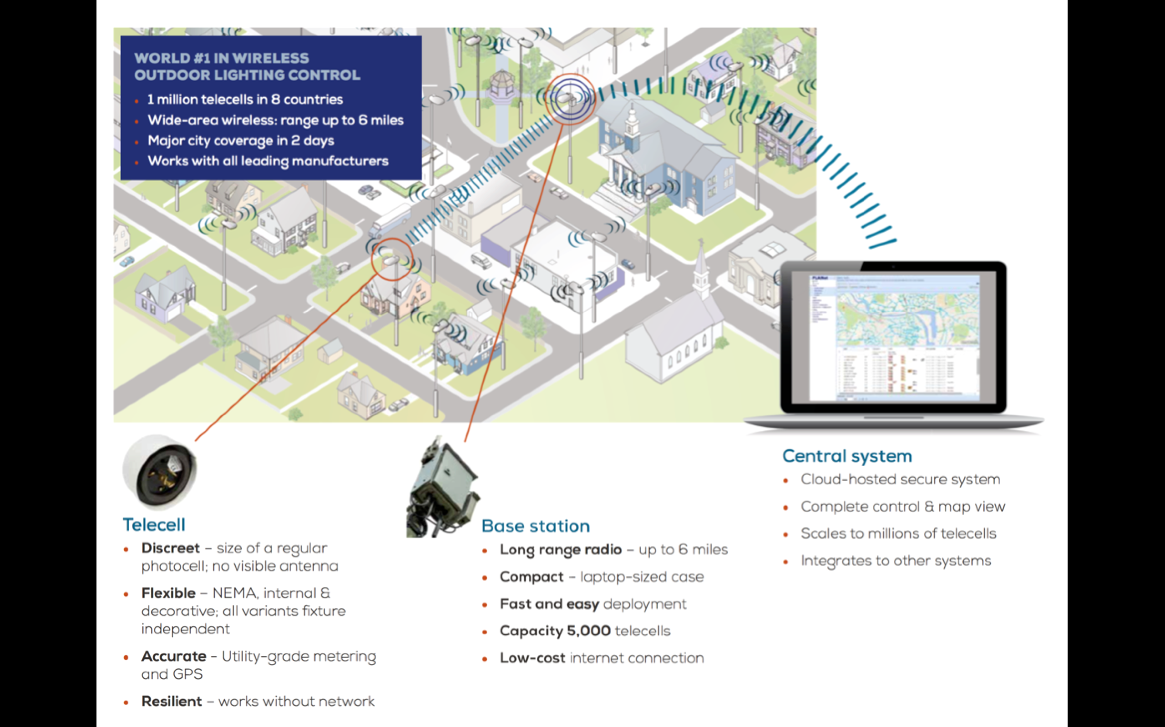

## Energy Saving Strategies Enabled by PLANet

**Dimming**

Fine-tuning lighting levels according to local requirements and dimming at times of low occupancy provide cost savings of at least 17%, even with a modest dimming program. Experience indicates that citizens’ acceptance of dimming is much greater than advance consultation indicates.

**Trimming**

Traditional luminaire-mounted photocells are prone to tree shadow, dirt and clouding of windows and are pre-set to compensate for their highly variable performance – the result is variable and early switching at dusk and late switching at dawn, wasting energy. By combining a sophisticated and accurate light meter on each base station, combined with programs that can vary switching times very precisely, savings of around 4% of peak priced energy can be achieved.

**Constant Light Output (CLO) and Maintenance factor (MF).**

Two factors affect all luminaire’s light output over time: lumen depreciation and build-up of dirt.

* **Constant Light Output**

PLANet can automatically compensate for lumen depreciation to provide a Constant Light Output (CLO), by under-powering the LEDs in the early years and progressively ramping-up the power over the whole lifetime. This may save in the region of 7% energy.

* **Maintenance factor**

Telensa’s CMS can be configured to compensate for MF, progressively increasing the power and light output to compensate for the build-up of dirt, then reducing when cleaned. Assuming a 6-year cleaning cycle, the effect is to save about 3% of energy.

**Optimized maintenance operation: reduced scouting, optimized logistics and parts management**

Night scouting has been the primary source of identifying and reporting lights not in operation and can represent a significant cost that can be eliminated at the same time as improving customer service and reducing maintenance costs. Compared to a typical scouting and maintenance arrangement of monthly scouting and 24hr repair, instant CMS fault notification plus 3-7 day repair time provides a significant improvement in luminaire outage time and dramatic savings in maintenance costs through better repair route planning, traffic management and logistics.

**Avoiding re-visits**

* Without a CMS, there is no way to centrally adapt light programming, such as in response to an increase in energy price or a change in local crime levels. Telensa’s savings model assumes just one visit to adjust dimming during the entire 15-year term or to correct time drift issues in the photocell/driver.
* The requirement for rapid response and the lack of asset and diagnostic information frequently means visits to lights that are not the responsibility of the utility/city or which have simply suffered a power failure, and re-visits because of lack of correct parts or the wrong fault being diagnosed. The CMS tackles these problems at the source by providing accurate asset information and real-time status and diagnostics.

**Telecell energy consumption**

Telensa’s CMS does involve using telecells that consume slightly more than photocells - 0.7W each compared to typically 0.25W for a photocell. This difference is considered in the modelling, but mesh and cellular wireless products typically consume far more, typically 2-3W.

## Business case breakdown

The following business case is based on data from more than 50 large-scale Telensa deployments. In this scenario, there are 18,000 street and roadway lights converting to LED. The savings are broken down at year 5 and profiled over the 15-year lifetime of the luminaires delivering a simple payback of just over 4.6 years.

## PLANet CMS: comprehensive, proven and scalable

***PLANet is the only CMS application with the power to show a wide area map view and easily manage urban, suburban and rural deployments from a single interface***

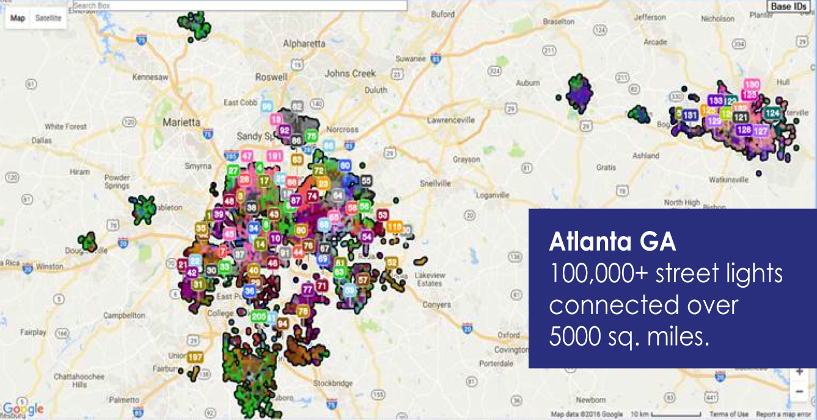**Key features**

Each TELECELL unit can measure an extensive range of parameters. Readings can be

returned using programmed monitoring or ad hoc interrogation. Measurable

parameters include:

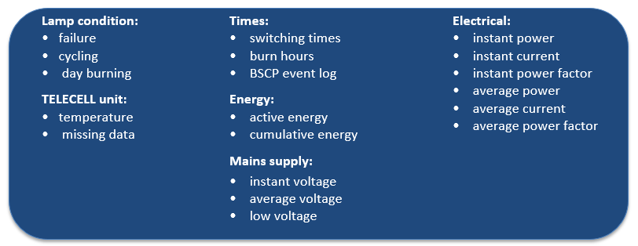

•

## Telensa UNB – the reason why Telensa Smart Lighting is the Market Leader

**Proven at scale**

Telensa’s proven Ultra-Narrow-Band (UNB) wireless technology is one of the most mature systems on the market and our underlying technology has proven itself in applications from parking to smart metering and stolen car tracking over the last 20 years. Through many optimizations to the system over the years, the technology is by far the most advanced Low Power Wide Area (LPWA) technology available.

The Telensa network planning system can use asset data or can simulate light locations and types.

It identifies the optimal pole locations to install base-stations. Most lights are covered by multiple base-stations for resilience. Unlike mesh networks, the network deployment is simple, takes only days to install, and can be performed either prior to or in parallel to the light fixture installation.

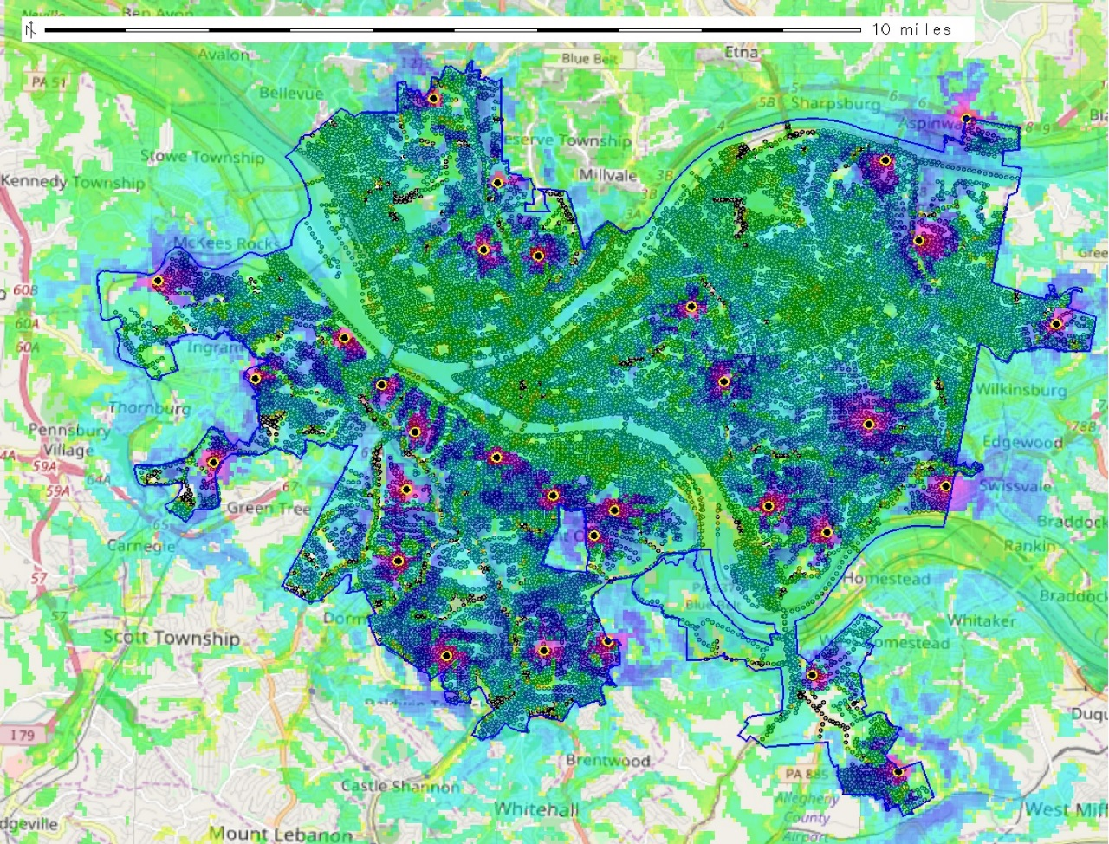

The image above is a map of the Pittsburgh area which Telensa has used to prepare a preliminary network propagation plan. Based on this network plan, only 31 Base Stations would be required to provide coverage of the estimated 40,000 street lights expected to be addressed under the City’s Smart Street Light initiative. Using this industry leading planning tool, Telensa is ready to deploy this network within days of receiving a notice to proceed.

**How does UNB compare to other systems?**

Predicted coverage of the UNB network for the City of Pittsburgh includes:

40,000 street lights

31 base-stations

Radio technologies all have their target market:

* C**ellular** is optimized for consumer voice and data traffic
* M**esh** was originally designed for local in-building control systems
* **Low Power Wide Area (LPWA)** systems such as Telensa UNB were designed from the start for wide area low cost sensing and control. Most of the interest in IOT is now focussed on these types of systems.



**Here’s why most of the interest is in LPWA:**

* **Lowest infrastructure cost** – requires 10x fewer base-stations compared to mesh, and no subscription costs like cellular.
* **Lowest energy costs** - with nodes requiring 10x less energy than mesh or cellular
* **Support for battery powered mobile devices** – mesh systems cannot support battery powered applications such as smart waste, smart parking, asset tracking etc.
* **Lowest support required** – LPWA is a deploy and forget technology. Mesh requires constant manual optimization of the network. Cellular blackspots can often not be overcome.
* **Low effort rollout** – our base-stations take 30 minutes to install, you turn it on it instantly covers a wide area. Mesh systems require complex planning of a backbone and road closure while the initial network is rolled out.

**You own it, you say how it is used**

A city owned network completely changes the dynamics of rolling out services:

* **Free connectivity** – no subscription charges unlocks the business case for many applications.
* **Total coverage** – as the owner of the network you decide which areas have coverage.
* **Guaranteed longevity of service** – no need to replace equipment when a network operator changes technology. For example, 3G will not be available in some places in 5 years’ time.
* **Applications for free** –Telensa does not control what is added to your network
* **Monetize access** – rather than renting someone else’s network occupying your lighting infrastructure, you can charge for access to sensor sites and application connectivity.

## Telensa UNB – Future Proof Smart City Network

**In assessing the future of a Smart City initiative, it is important to ask two questions:**

* Is my smart city system based on open standards?
* Will it support the growing mass of future smart city applications, standards and frameworks?

**Telensa Smart City – built on Open Standards**

Telensa Smart City builds on some leading open standards ensuring interoperability and enabling cities to select from a set of technology providers.

* **ETSI-LTN:** At the network level Telensa UNB is based on ETSI-LTN, the only active standards body for LPWA which includes Sigfox, Sony, and Fraunhofer and the LoRa Alliance
* **IPv6:** Telensa uses standard IP connectivity and the latest security frameworks to ensure seamless connection over multiple backhaul mechanisms including cellular, Wi-Fi, Ethernet and fiber.
* **TALQ:** At the application level, Telensa is on the board of the TALQ Consortium which includes other leading companies including Cisco, Schreder, Philips and GE. The group is currently working to define a common framework that covers a wide set of key smart city applications.
* **BSI-CSI:** At the city governance level, Telensa sits on the board of the Cities Standards Institute which has developed the most widely adopted guidelines for planning smart city policy.

## Telensa Smart City – ready for whatever happens in smart cities

Nobody knows which standards and systems will emerge as winners in the emerging smart cities landscape.

We believe in giving our customers the widest possible choice to use new standards as they emerge. As a result, we have developed a set of APIs that support all current and envisioned standards.

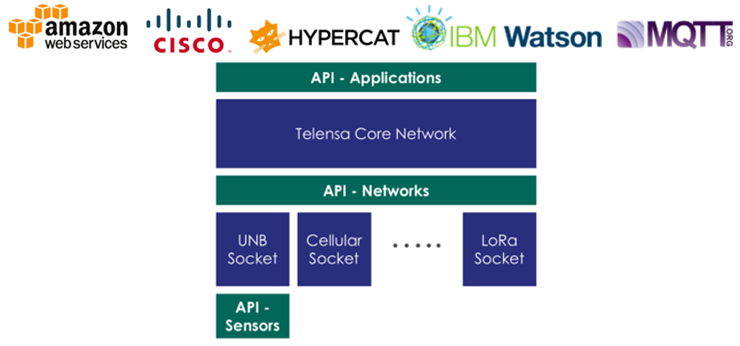

* **At the application level** – this API enables connection to all the emerging smart city platforms including Cisco CDP and Hypercat.
* **At the network level** – this API provides a socket connection to enable interfacing with a wide set of communications systems.
* **At the device level –** this API allows any smart city device vendor to connect their products to the UNB network.

## Rapid Interfacing Methods

**To accelerate smart city device integration, Telensa provides two rapid interfacing methods:**

**Telensa Smart Box**

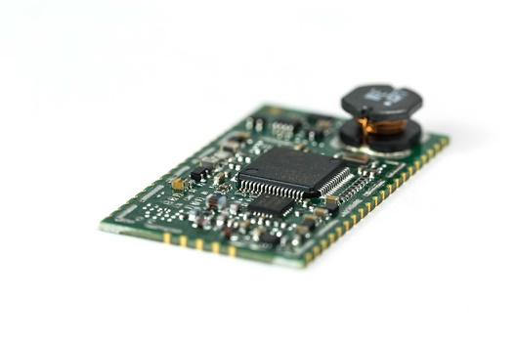The Smart Box enables easy connection into the UNB network for any device that supports Bluetooth, Wi-Fi, UNB or a set of other wired interfaces. The Smart Box also includes a powerful processing platform that can be used to undertake analytics such as video processing or data manipulation.

**Telensa UNB Module**

The UNB module is a low cost, low power UNB modem ready for integration into a vendor’s device. It enables UNB connectivity with very little design effort. It is suitable for battery powered high volume devices.

## What services can I add to my smart city system?

The Telensa system provides complete flexibility to add nearly any smart city application. Below are a few examples of “City-Centric” applications we have deployed for our customers that deliver true value and can be easily monetized as real savings to the City of Pittsburgh:

**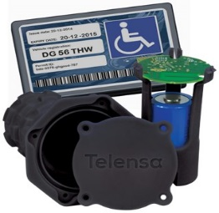Highways**

**Smart Parking**

Telensa delivered a 5000-unit smart parking system to Moscow in 2013 which at the time was the largest deployment in the world. The technology has since been used in multiple countries. We are currently integrating a video based system that will significantly lower cost and avoid the need to install road mounted sensors.

**Road Temperature Measurements**

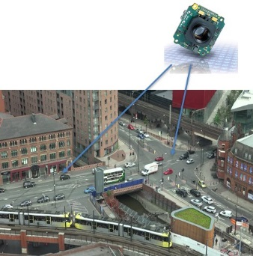Telensa is working with two local authorities to assess the effectiveness of localized road temperature measurements. Local road temperatures can vary by +/- 10 degrees so it is not sufficient to simply use weather forecasts to decide when to trigger a salt truck roll. By employing advanced weather and road friction analytics, municipalities could save millions of dollars and thousands of productive man-hours by knowing precisely when and perhaps more importantly when NOT to deploy salt trucks or snowplows.

**Intelligent Transportation Analytics**

As part of the flagship City Verve smart city project, Telensa is developing an ultra-low cost video analytics solution for street lighting poles. By putting processing at the camera and using UNB, we aim to provide ubiquitous traffic monitoring throughout a city. This innovative approach will radically change the economics of real time traffic control, enforcement, city route analysis and remove the need for manual traffic surveys.

**Environment**

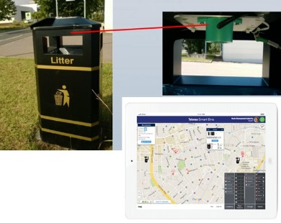**Smart Trash Monitoring**

Telensa is working with a major waste contractor to develop a low cost smart monitoring device that can be used across a range of public and commercial waste receptacle types. The system uses advanced analytics to predict when bins will become full and therefore trigger a collection team only when necessary. While there are several products on the market, this will be the first to use LPWA technology and so radically reduce the operational costs of this application.

**Smart Drainage Monitoring**



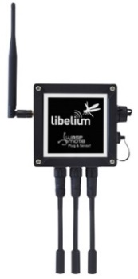Overflowing culverts and drainage systems can cause a significant amount of damage and lead to traffic disruption. However, the budget that cities have for managing these key assets is relatively small. Telensa is working with a leading manufacturer to develop the world’s first low cost culvert sediment sensor. As well as avoiding disruption caused by overflowing drains we hope to demonstrate key operational savings.

**Air Quality Monitoring**

Telensa is working with the global leader in air quality measurement cells to integrate their innovative smart diffusion tube product. By integrating with the Telensa UNB network we’re able to provide real time, highly localized data about air quality. So rather than receiving non-localized information from high cost measurement stations or weekly reports from localized devices, municipalities will now be able to get highly localized real time data. As well as this new innovative product, Telensa has integrated the Libelium set of smart devices, which provide a catalogue of over 200 sensor types.

**Public Engagement / Entertainment**

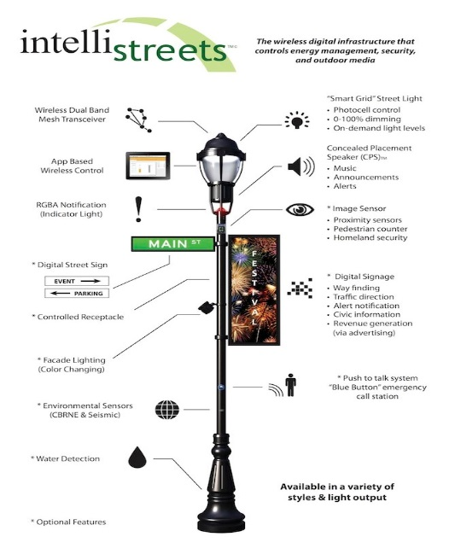As part of our open platform and ecosystems, Telensa easily integrates with top-tier developers of Smart City products designed to provide connected, intelligent and truly interactive public engagement services that can be implemented the city on a No-Cost or Revenue-Sharing basis. These systems also link to public transportation and city wayfinding applications that can enhance the experience for visitors to the city.

**IntelliStreets – Enabled Lighting**

IntelliStreets designs and deploys next-generation street lighting that opens innovative, new opportunities for public engagement, security, and entertainment that include:

* Decorative Lighting with Multimedia capabilities
* Concealed Placement Speaker
* Security Alert Indicators
* Blue Button - Emergency Call Station
* Digital Signage / Banner
* Image Sensors / Camera (Scalable)
* Environmental Sensors

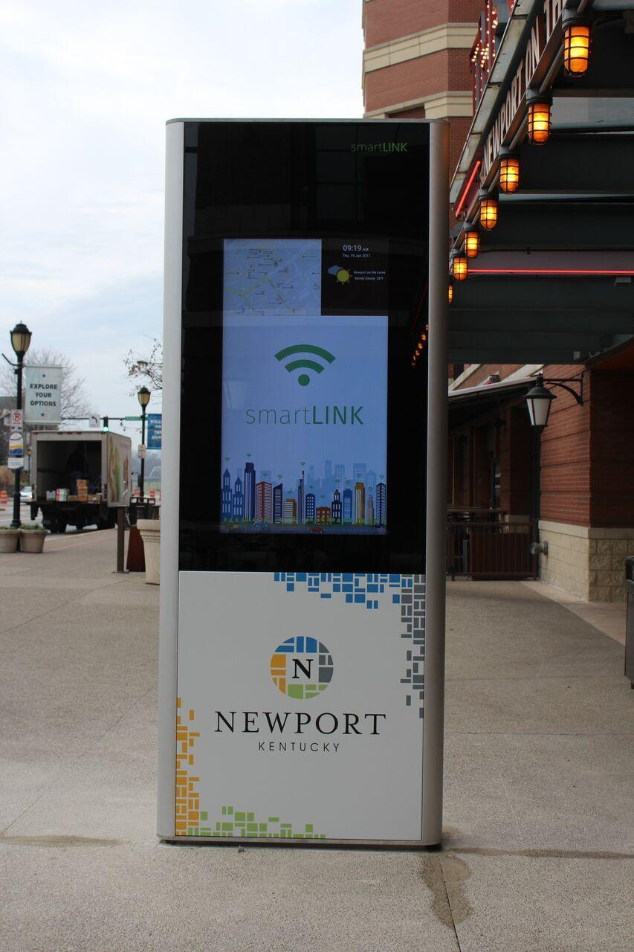**smartLINK – Public Engagement Kiosks**

smartLINK is focused on providing innovative smart city products to cities and campuses around the globe. smartLINK kiosks deliver an enhanced visitor experience and can be leveraged to provide public service and advertiser-supported event messaging:

* Interactive Video Display software
* Wayfinding management software
* Video analytics software platform
* Marketing Content Marketplace
* Mobile device ready wayfinding
* Analytics dashboard

## City-Directed Small Cell Network

Under a Managed Delivery Model, we can arrange for our partners at Nokia to aggregate all the deployment requirements for a Small Cell network on behalf of the City of Pittsburgh. What this means is Nokia would not maintain a traditional neutral host Small Cell network similar to Crown Castle or Mobilitie. This type of model is most beneficial to Pittsburgh and would protect the City’s interests due to the fact that under this type of model, the City would maintain the direct leases with the wireless carriers and collect 100% of revenue generated by the lease/franchise agreements. We suggest a more detailed discussion into the process and benefits of this model.

## Telensa – Innovation Being Implemented Today

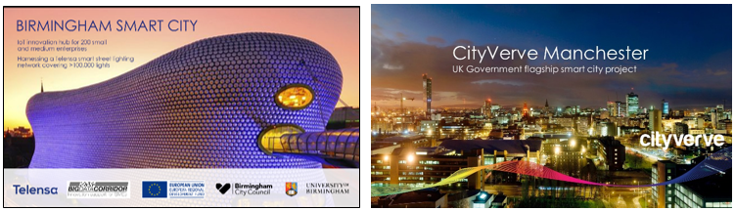Telensa is at the forefront of global Smarty City innovation. Recently, Telensa won a competitive grant from the European Commission to deliver Smart Boxes to companies in Birmingham, U.K. working in conjunction with these companies in developing innovative solutions to global urban problems.

Similarly, in Manchester U.K., Telensa was selected along with a team including Cisco and British Telecom to work with the city in developing the UK Government’s flagship Smart City program “City Verve”. The stated goal of this initiative is “Creating a Blueprint for Smarter Cities worldwide”. Telensa is setting the pace for Smart Cities around the globe.

## Telensa – Delivering a Proven Platform NOT a Pilot

Over the past decade, Telensa has built a global portfolio and solid reputation as the world leader in successfully deploying street and roadway lighting control and asset management systems. Our expertise in this area has been built on our team’s knowledge and lessons learned from real-world, large-scale street light control system implementation NOT a series of pilots consisting of a few thousand lights. Below is a list of projects with more than 10,000 lights Telensa has successfully completed within the past few years.

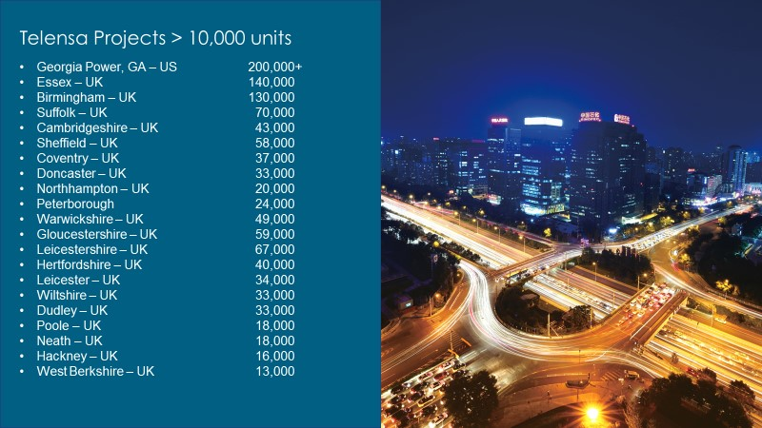

One project that may be of interest to the City of Pittsburgh is the street light control system in **Harrisburg, Pennsylvania**. This system was successfully completed in 2015 and is comprised of over 4,000 cobra-head, decorative, and roadway lights. The city is quite pleased with the system and is now looking to add additional Smart City applications to the Telensa UNB network. Mr. Wayne Martin, City Engineer for Harrisburg can be contacted to learn more about his experience with street lighting controls and Telensa.

## Conclusion

Since a comprehensive Smart Streetlighting Program, like the one being considered by the City of Pittsburgh, represents a long-term investment and partnership you must be certain that the company you partner with has the experience, longevity and stability to stand behind the work performed. Based on the information presented in this brief submission, the City of Pittsburgh can rest assured that Telensa is perennially one of the strongest, most financially stable smart city companies in the world.

Finally, and most importantly, we stand behind our work. As an organization that lives and thrives by successfully collaborating with cities around the world, we take pride in going the extra mile to achieve customer satisfaction. Our business is built on strong references and we do everything within our power to ensure that every customer views working with Telensa as a very positive experience.

We hope to have the chance to earn the right to take the next step with you and together develop a sustainable, secure and truly Smart Streetlighting program that will deliver multiple levels of value to the residents, visitors and administration of the City of Pittsburgh well into the future.