

April 3, 2017

Thoryn Simpson

Senior Procurement Analyst

Office of Management and Budget City

County Building, Room 502

Pittsburgh, PA 15219

Email: thoryn.simpson@pittsburghpa.gov

RE: Request for Information for Smart Streetlights (RFI No. 2017-0001)

Dear Mr. Simpson:

On behalf of Verizon, we thank you for the opportunity to propose our response to the City of Pittsburgh’s Smart Streetlight Request for Information. Our goal is to partner with the city to dramatically improve the quality of life for the citizens of Pittsburgh. We plan to do this by collaborating with the required city agencies to develop a Smart City Roadmap which will be used to help execute on the Smart Pittsburgh vision. We are excited to continue discussions and explain further how Verizon can assist Pittsburgh to design, deploy, operate and fund smart connected city services.

**Why Verizon -** **Verizon touches over 140 million people daily. We use that understanding as a foundation to help shape a city environment that can best serve the needs of your citizens. Our proven track record of working with organizations to solve public - private infrastructure challenges demonstrates our ability to provide world-class service, innovative ideas and long-term capabilities. Our goal is to provide the most advanced technologies to the City of Pittsburgh.**

* Verizon has successfully implemented extensive fiber infrastructure in virtually every major metropolitan area in the United States, as well as internationally in over 130 countries.
* This expertise along with our recent Sensity acquisition, with over 40 Smart Lighting/City deployments, brings a unique value to the City.

We are confident in the strengths that we bring to Pittsburgh:

**History of Partnership – Verizon continues to make significant network investments in the Pittsburgh/Allegheny market and is active in the local community.**

* Verizon has sponsored the Penguins since 1992 and offers 4GLTE at the PPG Paints arena.
* Verizon has made Philanthropic Investments in Pittsburgh on an ongoing annual basis. Of that, some have been awarded from Verizon Hopeline to the Women’s Center of Pittsburgh to fund a crisis intervention program for victims of intimate partner violence.

**Financial Strength and Stability** **– As a Fortune 15 Corporation in 2016,** **Verizon brings solid financial strength ($125.9 B total operating revenue). In addition to providing reliable wireless and wireline telecommunication services, we have a diversified portfolio of enterprise business solutions. Over the last several years, we have carefully executed Mergers & Acquisitions in several key IOT areas which differentiate us in the market:**

* **2015 – AOL:** Verizon acquired AOL to further drive its LTE wireless video and OTT (over-the-top video) strategy. The acquisition also supported and enhanced Verizon’s IoT (Internet of Things) platforms, creating additional revenue growth opportunities spanning consumer, business, and municipal sectors.
* **2016 – LQD:** Digital kiosks capture Verizon’s vision of delivering citizen engagement experiences by connecting citizens and visitors with local communities while providing critical security, way-finding solutions, and Wi-Fi and revenue generation capabilities.
* **2016 – Sensity Systems:** Sensity brings a comprehensive portfolio of Smart City solutions and a wealth of experience in successfully deploying these solutions, with over 40 Smart City deployments around the globe. Sensity has enabled municipal lighting owners to not only capitalize on energy efficiency and cost savings related to LED / lighting control upgrades, but also facilitated the achievement of community goals such as traffic management, public safety, parking control, asset management and sensor- based analytics.

We, at Verizon, look forward to supporting Pittsburgh’s present and future goals. We sincerely appreciate your consideration and would be honored to embark on conversations on how we can best partner to introduce innovative solutions and leverage the value of city assets both physical and digital, for this and future smart community services. With the diverse array of Pittsburgh City assets and our solutions and proven experience in planning, implementing, operating and financing city-wide solutions, we are confident that we can achieve mutual success together. Should you have any questions or require clarification on any aspect of this response, please contact us by email or at the phone numbers listed below.

We acknowledge that all responses may be considered public information in accordance with the Commonwealth of Pennsylvania Right to Know Laws as described in Section 5 of the RFI document.

Sincerely,

Amy Cecchini, James Lee and Lex Calder

**Amy Cecchini**

Major Accounts Manager Gov’t

Wireless Operations

300 Allegheny DR

Warrendale, PA 15086

4125088238| [amy.cecchini@verizoniwireless.com](mailto:amy.cecchini@verizoniwireless.com)

**James Lee**

Business Development Manager – Smart Communities

Verizon Enterprise Solutions

1 Verizon Way

Basking Ridge, NJ 07920

908.331.0868 | [james.lee2@verizon.com](mailto:james.lee2@verizon.com)

**Lex Calder**   
Manager - Solutions Architect

Wireless Operations

650 Boardman Poland RD  
Youngstown, OH USA 44512  
330-317-1611 | [Alexander.Calder@VerizonWireless.com](mailto:Alexander.Calder@VerizonWireless.com)

**Project Overview**

Verizon recommends a project roadmap that will include full LED conversion and Smart Lighting Controls for Pittsburgh’s approximately 40,000 existing fixtures. The project will include additional smart city solutions the city deems valuable in areas of the city where the solutions provide the most benefit. Our Sensity Lighting Control platform will enable these additional solutions while conforming to Penn DOT requirements. Our recommendation is that we also deploy approximately 50 digital kiosks as part of the project that will dramatically improve citizen engagement and potentially provide substantial revenue generation to the city to help fund the LED conversion.

***Smart City Solutions enabled could include:***

***Intelligent Video Solutions:*** *Public safety*

***Intelligent Traffic Solutions:*** *Assist with Vision Zero Initiatives, Enhance signal optimization, Reduce congestion & travel times, Reduce emissions*

***Intelligent Parking Solutions:*** *Real time parking availability, parking enforcement benefits, reduce travel times*

***Managed Wi-Fi:***

*Increase digital equity for citizens and visitors*

***Environmental Sensors:***

*Real time analytics around climate and other environmental sensing, pedestrian and vehicular counts, flows and classification*

***Digital Kiosks:***

*Improve citizen engagement, expand Wi-Fi, and augment public safety*

**Intelligent Traffic**

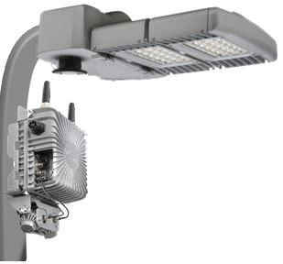 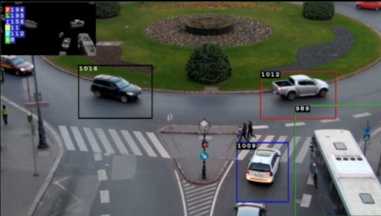

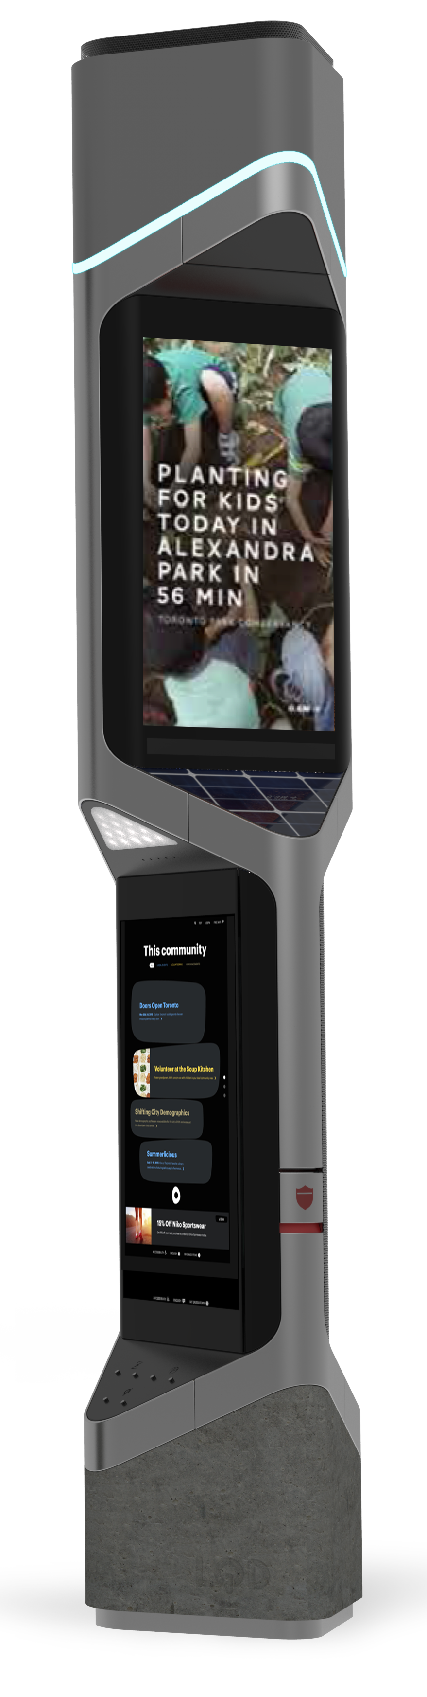 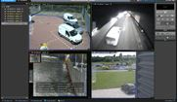

**Public Safety**

The solutions can utilize existing city assets including but not limited to light poles, traffic poles, street furniture, sidewalks and city owned buildings. Verizon Smart City Solutions have been deployed in over 40 cities globally and we would be happy to share details of the deployments and the specific challenges and use cases these technologies are helping solve for in later discussions under NDA.

**Deployment Plan**

Verizon proposes a three phase deployment approach to expand the various components of our Smart City solution portfolio while aggressively rolling out the street light LED/Controls upgrades. A mutually agreed upon project deployment plan will be finalized with the city; the following sample deployment plan is for planning and discussion purposes:

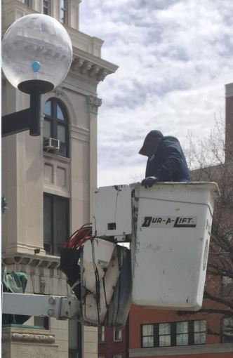

***Verizon recommended areas of the City for Smart City Solutions:***

***Downtown/Uptown:***

*Business district/technology zone/PPG arena.*

***Hill District:***

*Low income area located contiguous to uptown PPG arena, and is a high priority development/improvement zone.*

***East Liberty:***

*Rapidly emerging tech and millennial neighborhoods.*

***Oakland:***

*University of Pittsburgh, Carnegie Mellon & Carlow.*

***Hazelwood and Homewood:***

*Low income areas identified for economic development investments.*

***Squirrel Hill/Shady Side:***

*High income residents with vibrant retail district*

**Phase 1 (Start – Month 6)**

* **Smart Street Light:** LED and Controls Upgrade – deploy first 15,000 street lights and associated controls.
* **Citizen Engagement Kiosk Deployment:** Install 15 public engagement kiosks at mutually agreed locations.
* **Managed Wi-Fi:** Light-up 5 zones across the City with the Verizon managed solution to provide Wi-Fi access

**Phase 2 (Months 7 -12)**

* **Smart Street Light:** Deployment of additional 15,000 street lights and associated controls.
* **Citizen Engagement Kiosk Deployment:** Deploy additional 30 public kiosks.
* **Managed Wi-Fi:** Light-up 5 additional public Wi-Fi zones across the City with the Verizon Managed solution.
* **Light Sensory (Video) Solution:** Deploy the Light Sensory solution set in several locations to demonstrate and validate extended lighting control, parking management, traffic management and public safety solutions.

**Phase 3 (Months 13 - 18)**

* **Smart Street Light** LED and Controls Upgrade – complete deployment with the remaining approximately 10,000 street lights and associated field controls.
* **Citizen Engagement Kiosk:** install remaining public engagement kiosks.
* **Expand the Light Sensory Solution:** Extend the deployment to additional locations to demonstrate and validate advanced light control, parking management, traffic management and public safety use cases.

**Verizon’s Project Management Methodology**

* Leverages Verizon’s Professional Services which is designed to help enhance Verizon networking and advanced communications solutions by providing professionally-certified experts who are seasoned in strategic service planning and delivery, and proficient in ITIL and PMI/PRINCE2 standards.
* Our dedicated project management team will work with the city designated individuals to ensure successful deployment.

**Technical Specification**

**LED Lighting and Controls**

Verizon’s Smart Street Light solution is a connected LED/luminaire control and analytics solution for energy and maintenance cost savings that is managed using the NetSense platform. The key components of the solution are Core Nodes and cloud-based NetSense platform.

The Core Nodes provide an expanded range of application possibilities beyond those of typical LED lighting and control solutions. These applications include proximity dimming, event logging, and a broad set of sensor solutions. Lighting Core Nodes come in several configurations to match a flexible range of lighting applications and luminaires. They include external versions that are installed via a standard 5/7-pin NEMA receptacle as well as an internally integrated version appropriate for decorative fixtures. The below table provides the technical specifications for the Core Nodes.

***LED upgrades with smart lighting controls bring:***

* ***Utility cost savings***
* ***Maintenance cost savings***
* ***Operational efficiencies***
* ***Real-time outage detection***
* ***Adjust lighting levels by time and situation***
* ***Core Node enables additional smart city solutions with power and connectivity***



**Managed Wi-Fi**

The Verizon Managed Wi-Fi solution is a simple, turnkey service that is managed from the cloud. The service includes a user-friendly dashboard that provides centralized management for all devices. A Service Level Agreement is available, providing service commitments on both the installation of the service and a time to repair commitment in case outages occur.

Smart cities need standards-based, fast, secure and extensible networks to provide the connectivity and time sensitive data required to unleash the next wave of city innovation.  Verizon Managed Wi-Fi is a proven technology to provide a practical and holistic approach for delivery of wireless connectivity to both people and devices with high levels of security and privacy including the ability to limit access and encrypt data. Verizon will provide Access Points on designated locations, including light poles or other city assets. The Verizon fiber network will connect these Access Points to backhaul data, including video feeds (if applicable). A ruggedized router will enable the Ethernet hand-off of the data to cloud– based applications and platforms.

**Citizen Engagement Kiosk:**

Our Digital Kiosks are designed to humanize the citizen engagement experience within urban communities. They do this by leveraging network connectivity to empower communities to address some of their most pervasive urban challenges. This could be anything from local commerce, bridging the digital divide, public transportation, parking, job creation/innovation, and urban planning. In addition, we believe that our kiosks will promote civic innovation and will deliver digital city services to your citizens.

As part of Verizon’s response to the City of Pittsburgh RFI, we are proposing a citizen engagement kiosk initial deployment. This will include kiosks across the City of Pittsburgh. The technical specifications for the Digital Kiosk are listed in the table below.

Kiosks contain engaging, community-based applications that can include:

* Wayfinding
* Real-time transit information
* Details on local businesses and offers
* Digital billboard for the City to post local jobs, volunteer opportunities, and community events
* Emergency Services and Notifications
* Two way 911 calling
* Bright street lighting around the kiosk
* Environmental sensor capabilities
* Internet access via Wireless Service (Wi-Fi)
* Enhanced cellular 4G & LTE connectivity

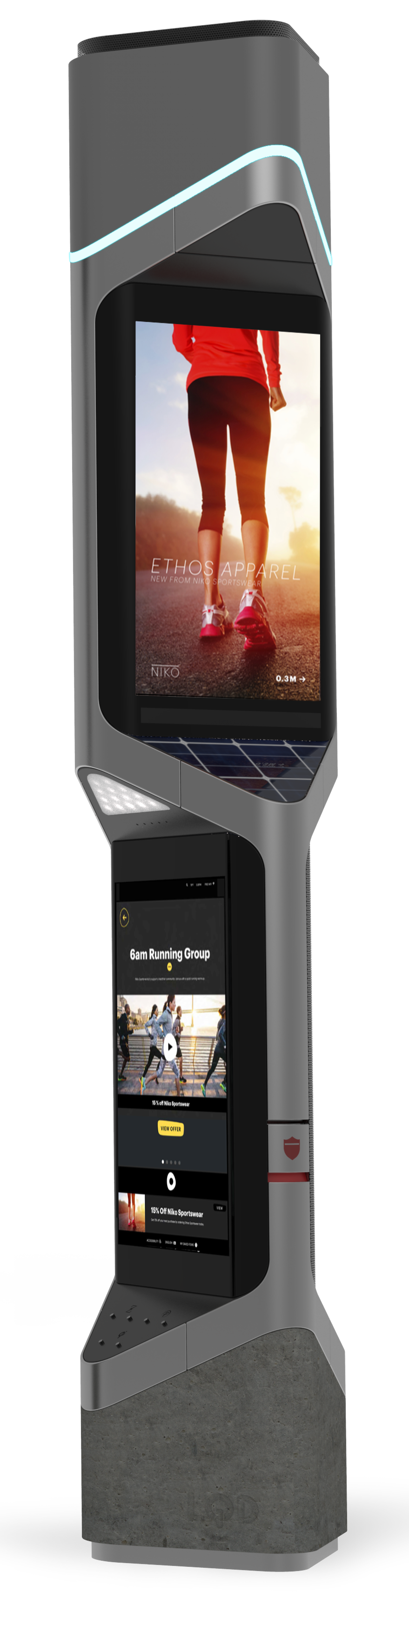

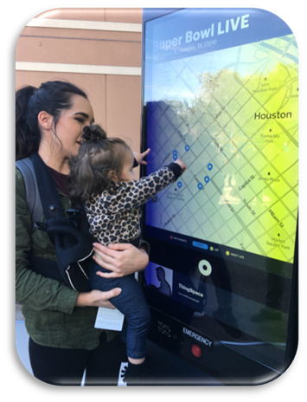 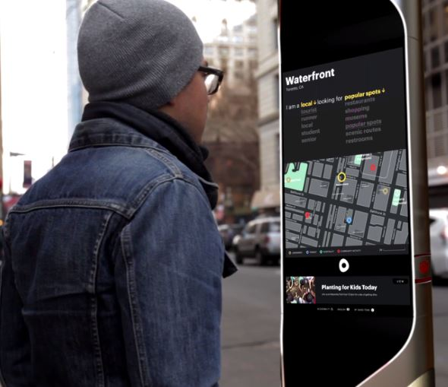

**Light Sensory Optical Nodes**

This innovative optical sensor includes a privacy-by-design approach allowing the system to perform data-intensive sensing through a system of distributed intelligence, picking out critical data at the street level, without requiring constant transmission to central servers. This unique capability transforms cameras from mere recording devices into multi-purpose, programmable sensors that send back only selected data (e.g. parking availability, traffic analysis) or relevant segments of video. In addition, each optical sensor stores up to 30 days of imagery. The below table provides the technical specification for the Video Node:

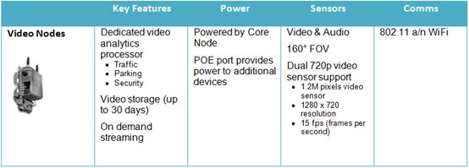

**LED upgrades coupled with core nodes and video nodes can provide real-time monitoring and analytics to the following scenarios.**

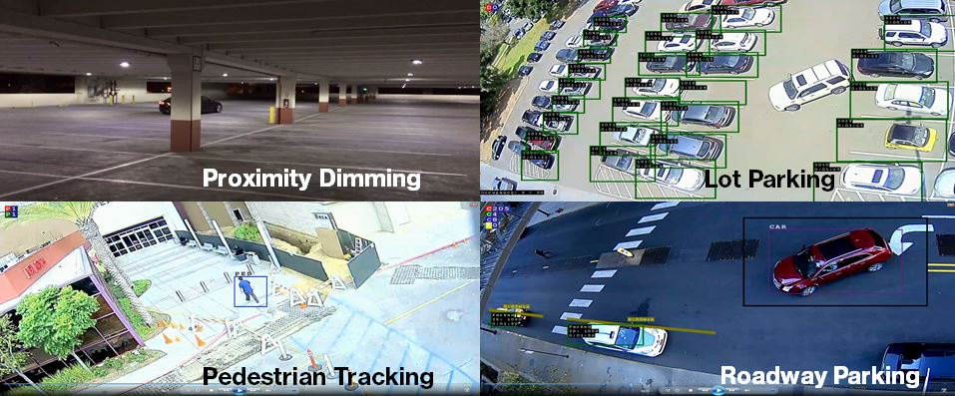

***Intelligent Traffic can assist with:***

* ***Vision Zero initiatives***
* ***Reduce delays and congestion***
* ***Signal optimization***
* ***Improve traffic safety***
* ***Pedestrian, cyclist and motorist detection***
* ***Enables proactive modeling***
* ***Near real time speed on roads (sub 5 minute latency)***
* ***Start to finish trip times and locations***

**Intelligent Traffic Management**

**Provides tools and analytics to better manage road and traffic infrastructure.**

Sensors embedded and installed at various points along roadways and intersections can communicate wirelessly to software residing in a secure cloud environment.

This solution allows authorized City users to access aggregated performance metrics such as speed, travel times, vehicle/bicycle counts, volume/capacity, turns and red-light violations, among other valuable traffic statistics.  This information can help the City and other transportation planning organizations effectively manage the flow of traffic.

By improving the driving experience with fewer stops and better fuel economy, citizen will be more attracted to coming into the city center. Additionally, the Verizon Intelligent Traffic Management portfolio includes an innovative set of tools that capture data directly from the Verizon Advanced 4G LTE network, aggregates and anonymizes this data, and, via sophisticated analytics software tools, provides the City with tailored traffic information for targeted roadways.  

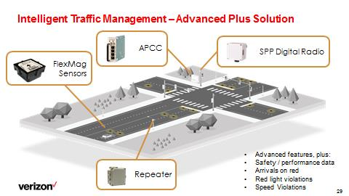

**Data Ownership, Transmission, Security, and Privacy**

***Highlights of Verizon’s Data Ownership, Transmission, Security, and Privacy include:***

* An integrated solution portfolio that supports security, data and privacy management.
* Verizon access and transmission networks provide end-to-end industry standard encryption between nodes and network gateways for data security and routing.
* Data security is provided at several layers, minimally using 128 bit encryption. Security is under the supervision and control of Verizon’s Network Operations.
* For security purposes, Verizon’s digital kiosks offer a custom-curated city experience which does not allow for direct access to the internet by the public.

The types of data collected by the various components of our solution (i.e. Public Wi-Fi, digital kiosks, etc.) are specific to the customer requirements and local regulations. Depending on the business agreement that becomes the basis of the partnership, there may be a range of data sources that are collected.

The Verizon privacy and regulatory teams will work hand-in-hand with Pittsburgh to create a framework that comports with local requirements. Verizon is working with several other cities on a best practice guide and playbook for smart city implementation and would welcome the opportunity to work with Pittsburgh on a Pittsburgh specific smart city best practice implementation.

In addition:

Our privacy team has pioneered a smart cities privacy approach and is working with City CIO’s and is the initiator of the Smart Cities privacy working group at the Future of Privacy Forum, a privacy think tank focused on building out privacy best practices for smart cities.

Sensity, a Verizon subsidiary, and Sensity’s smart City nodes have received a status of “Designated” under the U.S. SAFETY ACT.

**Operational Considerations**

A minimum Design Life of 10-years is projected for each of the components included in this solution. This is dependent on proper handling and installation of components by qualified and approved sub-contractors.

The annual field failure rate of the control nodes and gateways (including manufacturer defects) is less than 0.01%. The Light Sensory nodes are IP65/IP66 compliant for environmental robustness against dust and moisture when installed following recommended procedures. All components are RoHS UL/CE/FCC Approved, and 100% tested and validated. Verizon’s Light Sensory Network solutions are mature and are commercially available today.

We have several case studies and references available where our Light Sensory Network solutions have been deployed for years in many major US Cities. Verizon can provide a fully Managed Service for the term of the contract for all of the proposed components or a mix of City managed and Verizon managed scenario. Verizon will work with the City to evaluate and select the best operational and financial model that fits the City’s needs.

**Business Model**

***Funding Smart Cities***

* ***Verizon Covers Cost of Kiosks***
* ***Broader Opportunity for Revenue Sharing Opportunity***
* ***Drive Economic and Community Development***

Verizon, in collaboration with the city, will develop a creative business model that will help fund the LED Upgrade project. As an example, in the model we will show energy savings, maintenance, cost reductions and added revenue generation from kiosk deployments and potentially other revenue generating options to prove out the model. We can also incorporate financing options as needed to make the Smart Pittsburgh vision a reality.

**Verizon Covers Cost of Kiosks & Provides Revenue**

**Sharing Opportunity**

Verizon is willing to discuss percentages of revenue share after Verizon has recouped the initial investment. Verizon covers the kiosk including the substantial investment in designing and manufacturing this state of art equipment as well as the costs of site surveys, installation, maintenance, power, connectivity, software, platforms, and Ad serving costs to its Ad Inventory/Delivery partner.

**Evaluation**

Verizon’s proposed platform for Pittsburgh incorporates several innovative solutions that will improve the City’s services and citizen quality of life. Verizon will collaborate with Pittsburgh to design solutions with measureable metrics that might include or expand on the following:

**Experience in Smart Communities**

Verizon’s Smart Communities organization consists of industry leaders in leveraging technology to driving improvements in communities around the world. In 2016, Verizon made two key acquisitions, Sensity Systems and LQD Wi-Fi, in order to ensure core assets required for City deployments were seamlessly integrated. These efforts have amassed a highly skilled team of ~200 people dedicated to smart cities that create solutions designed to include job growth and innovation by the local community.

**Citizen Engagement Focus**

Verizon’s smart City solutions (especially digital kiosks) are built with citizen engagement, the creation of local innovation and economic development at its core. We believe those who live in the community are the most knowledgeable as to solutions that will work for the community. Thus, Verizon Smart Communities are designed to engage the community with solution creation upfront. The Verizon Smart Community solutions also enable broadband availability in areas previously difficult to support with a holistic business model that collectively allows for investments to cross economic boundaries and reach those who need the solutions the most.

**Digital Access to City / Public Services**

1. Citizens accessing kiosks to city systems, internet sites, email, etc.
2. Citizen smart devices/PCs accessing public to city systems, internet sites, email, etc.
3. Number of community notices and local events posted

**Public Safety Metrics**

1. Number of broadcasted emergency messages (via public, via kiosk)
2. Number of 911 calls (via or kiosk) that resulted in a physical response
3. Number of times the security cameras (kiosk, light pole) used to help solve an incident

**Leveraging Connectivity Infrastructure Investment**

Although smart City solutions may be deployed over a longer period of time, each one of them requires connectivity. As much holistic planning for this as possible can maximize the use of the fiber as well as minimize cost and neighborhood disruption. Verizon is uniquely positioned to support Pittsburgh initiative principles: multiple benefits with each activity, work in layers for independently effective solutions, and develop adaptive, flexible strategies.